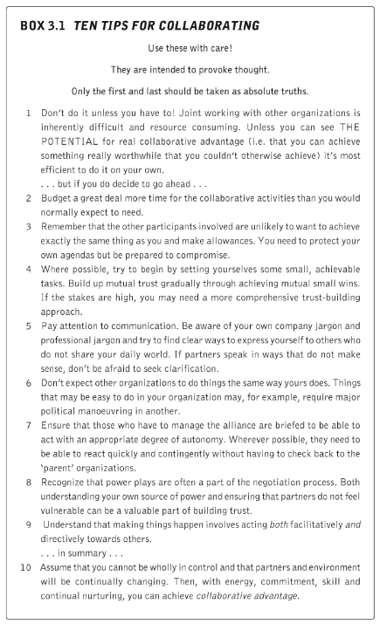In-text citation:

(Huxham & Vangen, 2005, p. 37)

Full reference:

Huxham, C., & Vangen, S. (2005). *Managing to collaborate: The theory and practice of collaborative advantage.* Taylor & Francis.